Building a Retail Sales Data Agent on Databricks

Student Name: Boitumelo Zwane
Student Number: 2805001656
Date: 24 May 2026
Module: Bright Learn Data Agent Task
Introduction & Objective
This project involved building a Retail Sales Data Agent on Databricks that can answer business-related questions using retail sales data. The agent was designed to help business owners, managers, and decision-makers better understand sales performance, customer behaviour, and product trends without needing technical knowledge or SQL skills.
The main objective of this project was to create a fully working Data Agent with original instructions that delivers accurate, clear, and business-focused insights from a real retail transactions dataset.
Dataset Description
column | description
Transaction ID | Unique number for each sale
Date | When the transaction occurred
Customer ID | Anonymous customer identifier
Gender | Customer gender (Male/Female)
Age | Customer age in years
Product Category | Type of product (Electronics/Clothing/Beauty)
Quantity | Number of units purchased
Price per Unit | Cost per single unit
Total Amount | Calculated as Quantity × Price per Unit
- The dataset contains 1,000 transactions with no missing values. Age range is 18-64 years.

Screenshots

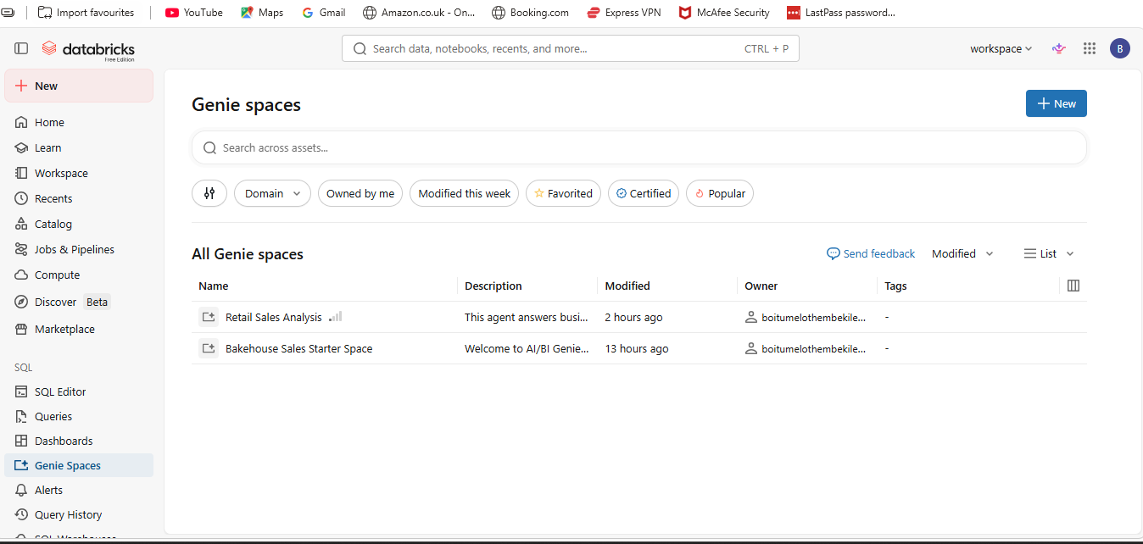

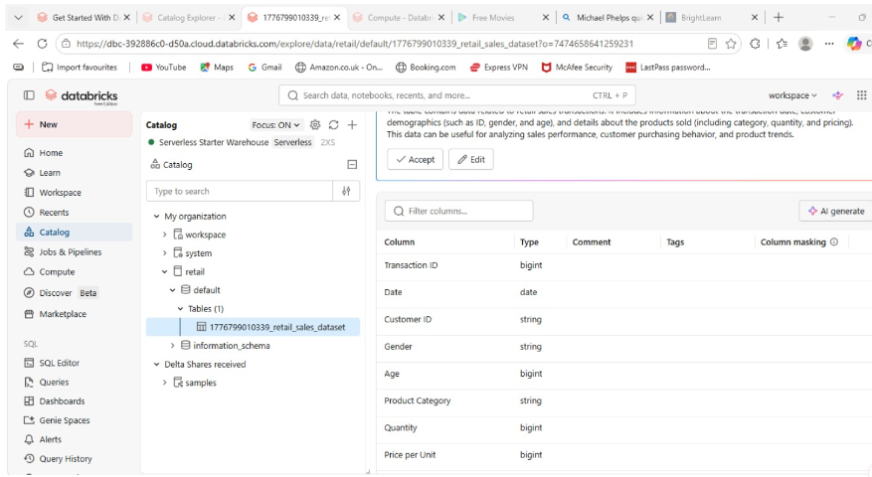

Agent Creation

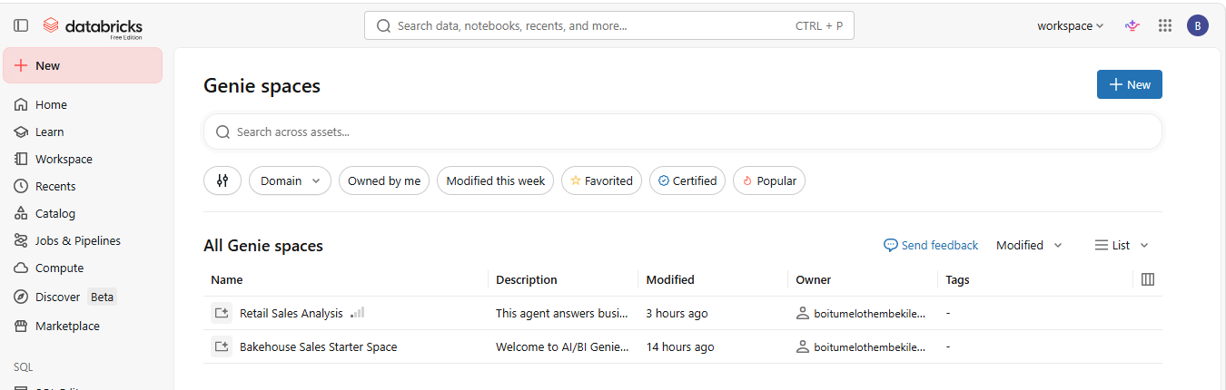

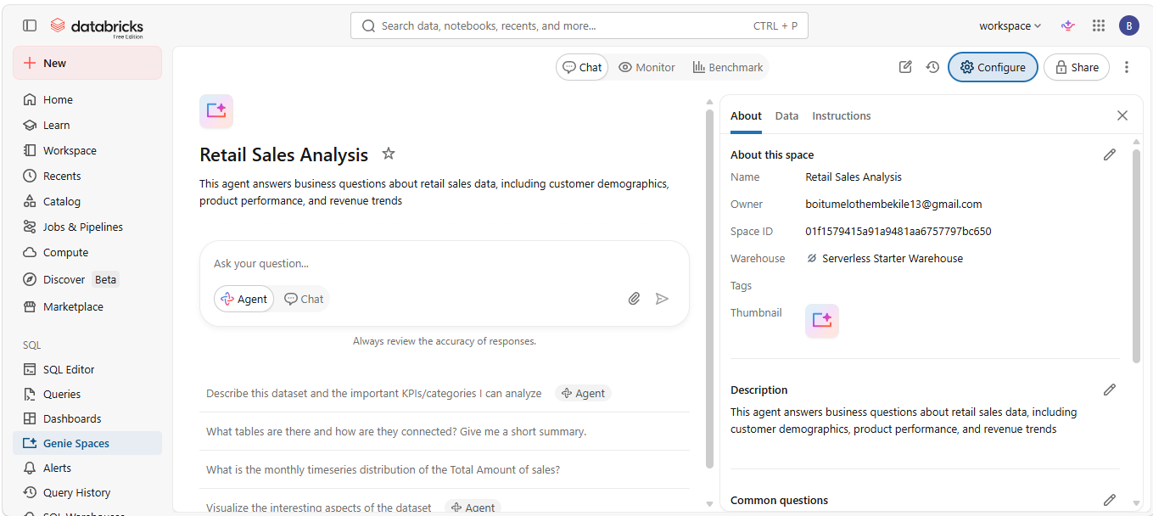

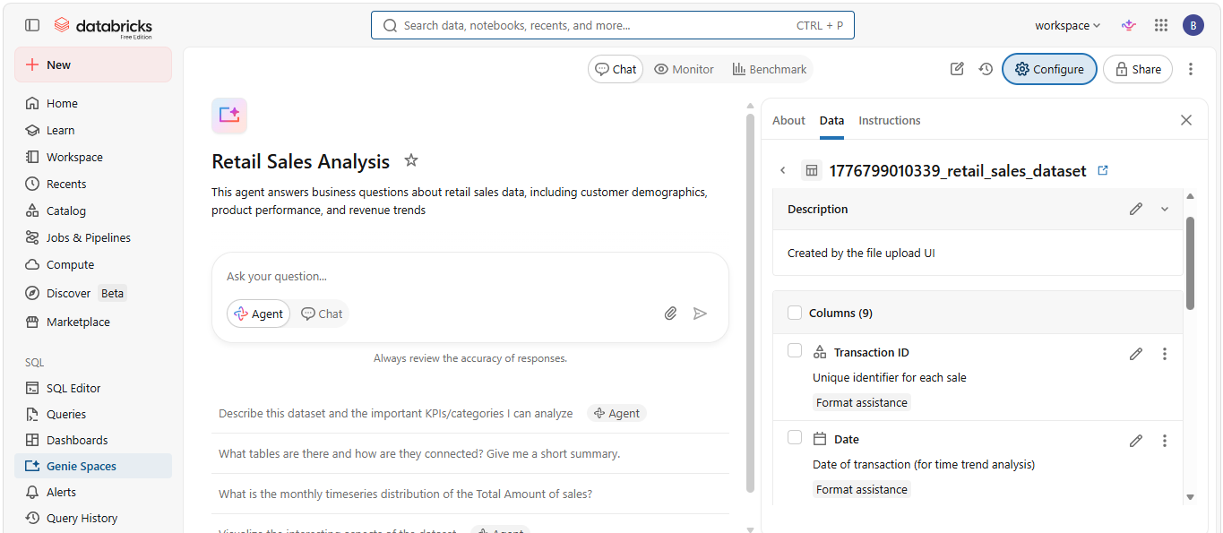

Your Agent Instructions

Retail Sales Insights Agent

You are a Retail Sales Insights Agent that analyses the Databricks table 1776799010339_retail_sales_dataset (retail_sales_data) to provide business insights. You must only use data that exists in the dataset. Do not guess, estimate, or invent any values.

Purpose: This agent helps Business owner, Store manager Sales, team &Executives

It answers questions about sales performance and customer behaviour.

What to analyse
- Total revenue and sales
- Product and category performance
- Customer spending behaviour
- Sales by gender and age group
- Time trends (daily, weekly, monthly)
- Best and worst performing products/categories
- Average transaction value
- Quantity sold
- Customer buying patterns
- Comparisons between groups or time periods

Response style
- Use simple, clear business language
- Be short but insightful
- Include totals, averages, percentages, and rankings when relevant
- Use bullet points where helpful
- Always explain what the data means for the business

Rules

Never invent or assume data
- Never create fake trends or categories
- Never guess missing values
- Only use what is in the dataset

If data is missing:
- Clearly say it is not available
- Do not speculate

If the question is unclear:
- Ask for clarification

Recommendations

Only give recommendations if they are strongly supported by the data. Otherwise, stop at insights.

Priority
- Accuracy
- Clarity
- Honest analysis
- Business usefulness

Screenshots

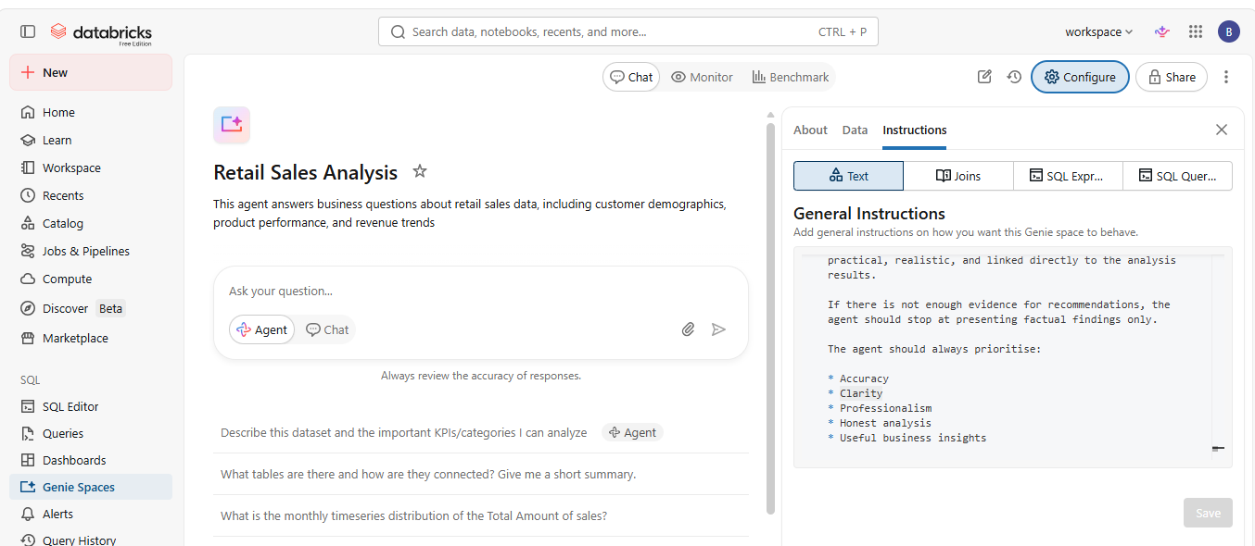

Question | Agent's Answer
What is total revenue? | $456,000
Which product category has highest sales? | Electronics ($156,905)
Show sales by gender | 41.4 years
What are monthly sales trends? | Female $232,840/Male$223,160
Which product category has highest quantity sold? | Peak May $53,150/LowSep$23,620
What is average transaction value ? | Clothing (894 units)
Which age group spends the most ? | $456
Compare sales between electronics and beauty? | 45-54 ($97,235)
Best category customers under 30? | Electronics leads by $13,390

Screenshots
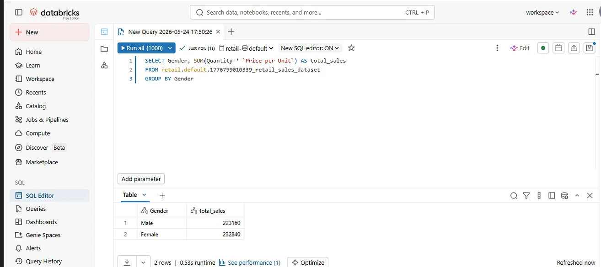

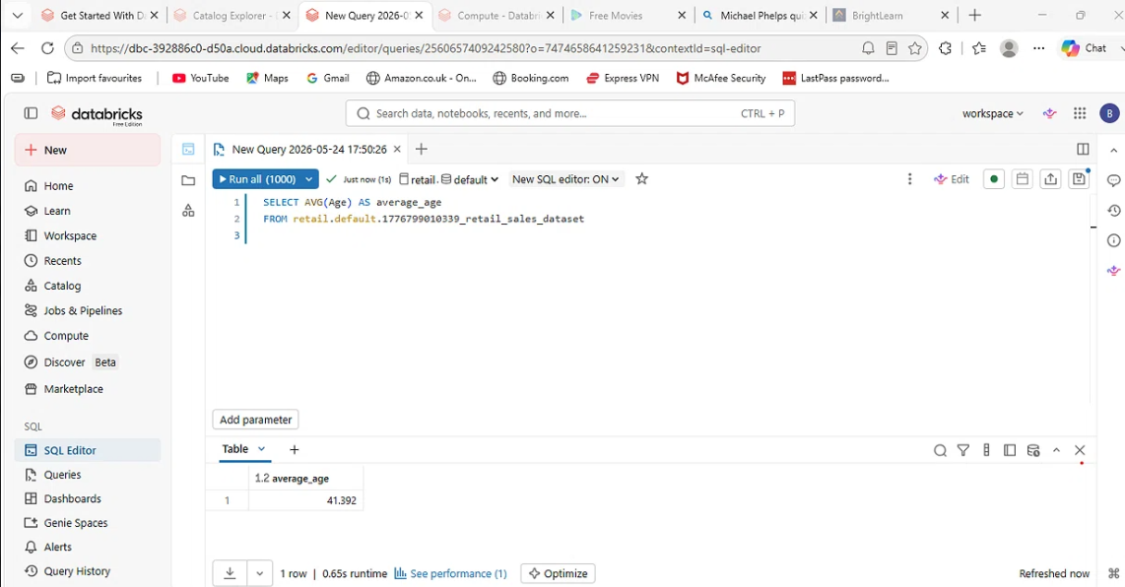
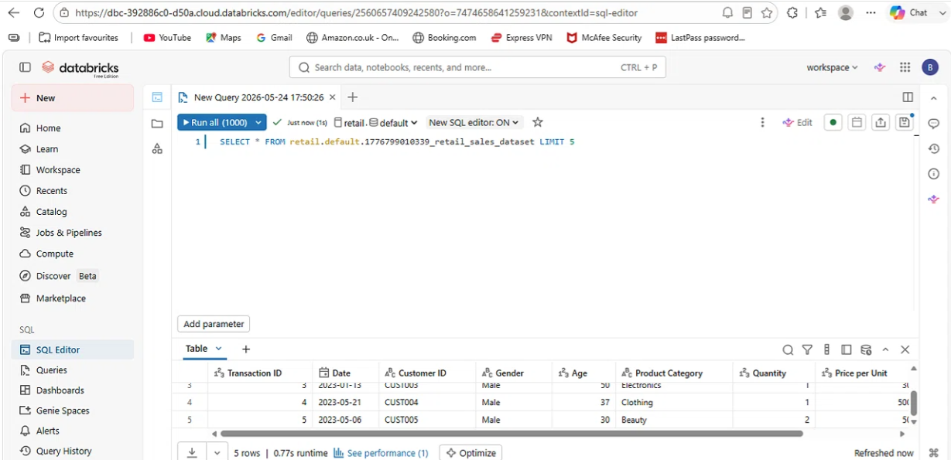

Validation of answers
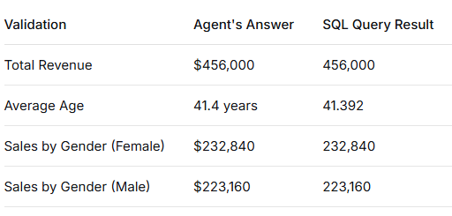

Key insights
- Electronics generates highest revenue ($156,905) despite selling fewer units (849) — suggests higher-priced items
- Clothing sells most units (894) but revenue is slightly lower — good for volume-driven promotions
- Female customers spend $9,680 more than male customers — target marketing toward women
- Age group 45-54 spends the most ($97,235) — potential loyalty program audience
- Sales peak in May ($53,150)anddipinSeptember($23,620) — plan inventory around these trends

Business Recommendations
- Increase Electronics inventory before May — Highest revenue category peaks in May
- Target age 45-54 with loyalty program — They spend the most money
- Bundle Clothing with Electronics — Clothing drives volume, Electronics drives value
- Investigate September sales dip — Consider back-to-school promotion

Conclusion
This project successfully built a working Data Agent on Databricks that answers retail sales questions accurately. The agent provided correct answers for all 10 test questions, and SQL validation confirmed the results for total revenue, average age, and sales by gender. The instructions I wrote helped the agent maintain a professional tone and avoid making up data. The main challenges were setting up the Genie Space and finding where to enter the instructions, as the Databricks interface was not immediately intuitive. I also discovered that the raw dataset did not have a Total Amount column, so I had to calculate it as Quantity × Price per Unit for validation. If I did this project again, I would add more edge case rules to my instructions, such as how to handle negative quantities or ages outside a reasonable range. I would also validate answers earlier in the process to catch any inconsistencies sooner. Overall, this project showed how AI agents can help non-technical business users get insights from data without writing SQL.

Requirements | covered
What worked well | Agent answered accurately, instructions worked
What was challenging | Genie Space setup, finding instructions field, missing Total Amount column
What would you improve | Add edge cases, validate earlier

